THE DEANERY ADMISSIONS FORM

PUPIL DETAILS

LEGAL SURNAME _________________________

SURNAME KNOWN BY (If different) __________________

NAME __________________________________

DOB ____________________________________

GENDER _______________________________________

ADDRESS
______________________________________________________________________________
__________________________________________________

POSTCODE _____________________

Please enclose a copy of your child’s birth certificate

If an overseas passport, then proof of residency is required

Date of entry into the UK

Date induction meeting completed –

Name of staff member hosting the meeting –

Please give a copy to student services to scan onto ARBOR

Please give a copy to the parent.

TRUTEX Uniform website https://www.trutex.com/

TRUTEX Uniform code LEA00960SC

CONTACT DETAILS
Please give details of those persons who live with the above pupil. Details of both parents are required unless there is a court order in place that prevents a parent from having access to their child or their information.

PARENT/CARER 1 RELATIONSHIP TO CHILD _________________________

SURNAME ________________________________ FORENAME______________________ TITLE _________ ADDRESS
______________________________________________________________________________
__________________________________________________ POSTCODE
___________________________
HOME TEL NO ____________________________ MOBILE
_______________________________________
WORK TEL NO ____________________________
PREFERRED EMAIL ADDRESS
______________________________________@________________________
Parental responsibility
I give/do not give permission for The Deanery to email/text me with important school matters (Delete as necessary)
Permitted to collect from school

PARENT/CARER 2 RELATIONSHIP TO CHILD
_________________________
SURNAME ________________________________ FORENAME______________________ TITLE _________ ADDRESS
______________________________________________________________________________
__________________________________________________ POSTCODE
___________________________
HOME TEL NO ____________________________ MOBILE
_______________________________________
WORK TEL NO ____________________________
PREFERRED EMAIL ADDRESS
______________________________________@________________________
Parental responsibility
I give/do not give permission for The Deanery to email/text me with important school matters (Delete as necessary)
Permitted to collect from school

Please give details of additional contacts who may be contacted in an emergency in order of priority including any other person with parental responsibility.

SURNAME ________________________________ FORENAME______________________ TITLE _________
RELATIONSHIP TO CHILD
___________________________________________________________________
ADDRESS
______________________________________________________________________________
__________________________________________________ POSTCODE
___________________________
HOME TEL NO ____________________________ MOBILE
_______________________________________
WORK TEL NO ____________________________
Permitted to collect from school

SURNAME ________________________________ FORENAME______________________ TITLE _________
RELATIONSHIP TO CHILD
___________________________________________________________________
ADDRESS
______________________________________________________________________________
__________________________________________________ POSTCODE
___________________________
HOME TEL NO ____________________________ MOBILE
_______________________________________
WORK TEL NO ____________________________
Permitted to collect from school

PRIORITY OF CONTACTS – MUST BE FULY COMPLETED

Please indicate the order in w hich contact should be made on a day to day basis or in the event of an emergency CONTACT 1
_____________________________________________________________________________
CONTACT 2
_____________________________________________________________________________
CONTACT 3
_____________________________________________________________________________ CONTACT 4
_____________________________________________________________________________

FAMILY DETAILS
Please give details of siblings at _______________________________________________ (Primary School)
NAME ________________________________________________ DOB
____________________________
NAME ________________________________________________ DOB
____________________________
NAME ________________________________________________ DOB

ETHNIC BACKGROUND

This part of the form is based on the new national population Census ethnic categories.
Please indicate below the ethnicity code which best describes you
Afghan |  |  | Indian |  |  | Roma
African Asian |  |  | Information Not Yet Obtained |  |  | Serbian
Albanian |  |  | Iranian |  |  | Singaporean Chinese
Arab |  |  | Iraqi |  |  | Sri Lankan Other
Asian and any other ethnic group |  |  | Italian |  |  | Sri Lankan Sinhalese
Asian and Black |  |  | Japanese |  |  | Sri Lankan Tamil
Asian and Chinese |  |  | Kashmiri other |  |  | Taiwanese
Bangladeshi |  |  | Kashmiri Pakistani |  |  | Thai
Black - Angolan |  |  | Korean |  |  | Traveller of Irish heritage
Black - Congolese |  |  | Kosovan |  |  | Turkish
Black - Ghanaian |  |  | Kurdish |  |  | Turkish Cypriot
Black - Nigerian |  |  | Latin/South/Central American |  |  | Vietnamese
Black - Somali |  |  | Lebanese |  |  | White - Cornish
Black - Sudanese |  |  | Libyan |  |  | White - English
Black and any other ethnic group |  |  | Malay |  |  | White - Irish
Black and Chinese |  |  | Malaysian Chinese |  |  | White - Scottish
Black Caribbean |  |  | Mirpuri Pakistani |  |  | White - Welsh
Black European |  |  | Moroccan |  |  | White + any other Asian Background
Black North American |  |  | Nepali |  |  | White and any other ethnic group
Bosnian-Herzegovinian |  |  | Other Asian |  |  | White and Black African
Chinese |  |  | Other Black |  |  | White and Black Caribbean

Chinese + any other ethnic group |  |  | Other Black African |  |  | White and chinese
Croatian |  |  | Other Chinese |  |  | White and Indian
Egyptian |  |  | Other ethnic group |  |  | White and Pakistani
Filipino |  |  | Other Gypsy/Roma |  |  | White Eastern European
Greek |  |  | Other mixed background |  |  | White European
Greek Cypriot |  |  | Other Pakistani |  |  | White Other
Gypsy |  |  | Other White British |  |  | White Western European
Gypsy/Roma |  |  | Polynesian |  |  | Yemeni
Hong Kong Chinese |  |  | Portuguese |  |  | Refused

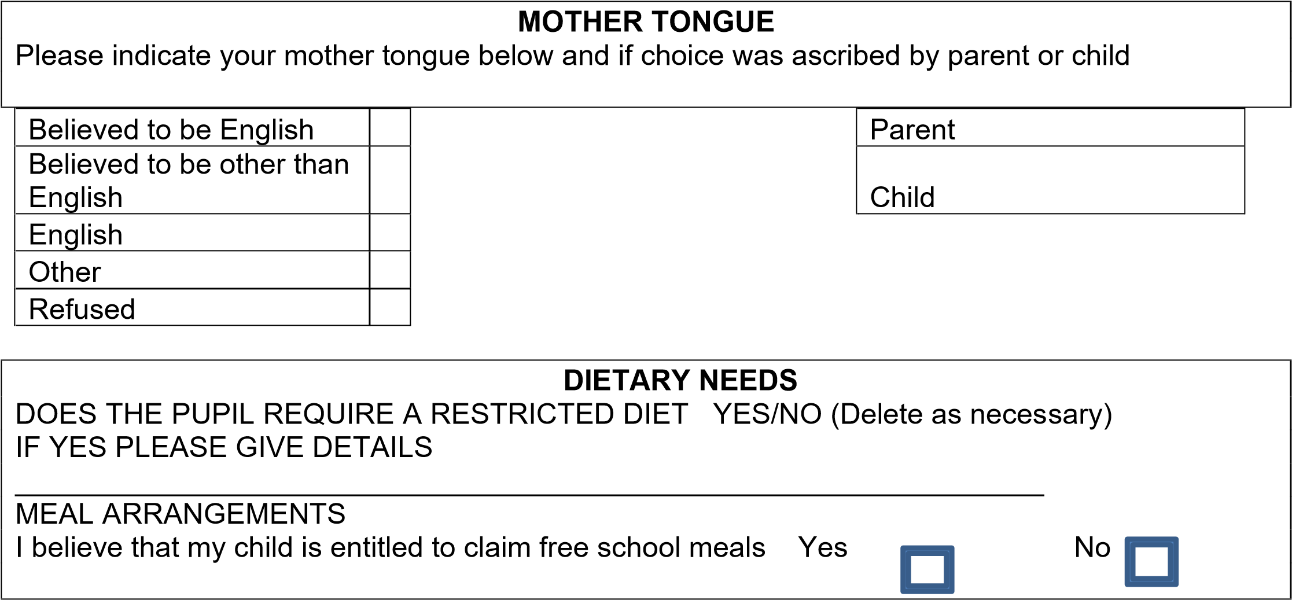

MEDICAL DETAILS

MEDIAL PRACTICE ________________________________TEL NUMBER ________________

DOCTOR’S NAME
_________________________________________________________________________
MEDICAL CONDITIONS
____________________________________________________________________
____________________________________________________________________
Please indicate if your child has a current Individual Health Care Plan Yes / No

TRAVEL ARRANGEMENTS
Please indicate your normal mode of travel to and from school. Please refer to the relevant guidance if necessary.
Bicycle / Train / Car or Van / Walk / Taxi / School Bus / Car Share / Public Bus Service / Other

SERVICE CHILDREN IN EDUCATION

Please indicate below if a parent or parents are Service personnel serving in regular HM Forces Military units of all forces and exercising parental care and responsibility.

I / we are members of the Armed Forces

I / we are not members of the Armed Forces

SCHOOL HISTORY

Please indicate the current / last school attended by the pupil ( INCLUDING OVERSEAS ) -
______________________________________________________________________________________

ADDITIONAL EDUCATIONAL NEEDS

Please give details of any additional educational needs of the pupil eg Impaired hearing, Dyslexia, gifted & talented, at their current school.

Is Your Child registered as a young carer Yes

No

PASTORAL AND SAFEGUARDING INFORMATION

Please let us know if your child is currently supported by any of the following plans or outside agencies.

Agency or support plan: | Yes | No
Early Help record
Team around the Child/Family
Child in Need plan
Child Protection plan
TaMHS
CaMHS
Social worker
Family Services

Other (Please state)

I confirm that I/we would like the pupil detailed on this form to be offered a place at The Deanery

Signed ______________________________ Print ________________________ Date
_________________
Signed ______________________________ Print ________________________ Date _________________

Please turn over and complete the Parental Consents

Parent Consents / agreements – PLEASE CIRCLE

Use of pupil photograph on website / social media Y / N

I consent for my child to leave the school premises, independently in the event of an
emergency / school closure Y / N

I have read and understood the school behaviour policy Y /N

I consent medical treatment via a first aid trained member of staff for example an ice pack
Y /N

I consent for a biometric thumb print to be taken for the purpose of using the canteen

Y /N

I have read and understood the uniform policy
Y /N

I consent for DBS checked adult to be present on school trips

Y / N

I have read and understood the school attendance policy including understanding that holiday during term time will not be granted and may incur a local authority fine

Y / N

I will take time to read The Deanery policies https://www.dcea.org.uk/policies/ relating to the following:

Charging and remissions Student friendly safeguarding
Code of Conduct RSE & RSHE
Education Visits Anti bullying
ICT acceptable usage Equality
Intimate Care Lockdown
On line safety
Positive handling
Pupils mental health
Supporting pupils with medical conditions
Safeguarding & child protection

