



Uniform policy

Version Control
Reviewer / owner (role) | Executive lead (role) | Approving body | Meeting date when the policy was approved
Executive principal | CEO and Executive  Board | Trust board | Email September 2024

This policy is reviewed annually / every two years / every three years.
The next review is due by

Introduction
The Trust intends and expects that all decisions, policies and procedures will be underpinned at all times by its vision and values.

Our aim:
To create centres of educational excellence that inspire all pupils to turn their potential into performance.
To achieve this our schools will:
- Provide a broad and balanced curriculum that allows pupils to develop their talents and ambitions.
- Deliver the highest quality learning opportunities facilitated by excellent teachers.
- Inspire our pupils to become confident, motivated and respectful individuals ready to make a positive contribution to society.

The Trust will support our schools by:
- Maximising the resources and expertise available to individual schools.
- Providing a platform for the sharing of excellent practice.
- Challenging and developing staff to turn their potential into performance.

Uniform and Presentation at The Deanery CE Academy
Uniform is an important part of the Deanery CE Academy; it is distinctive, innovative and aspirational. The uniform has been designed to be comfortable to wear, smart looking and practical.
Students will present themselves in a professional and smart way at all times; on the way to the academy, during the day and on their way home.

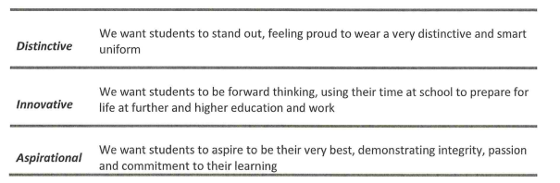

School uniform
Item | Supplier | Notes
Branded Blazer | Trutex | A compulsory piece of uniform; it must be worn every day, throughout the day. In extremely hot weather, the headteacher may decide blazers can be removed.
White shirt | Any | White, buttoned collard shirt (can be short sleeved). To be tucked in.
Tie | Trutex | A compulsory piece of uniform
Purple jumper | Any | An optional piece of uniform.
Trousers | Any | Must be charcoal grey, straight legged trousers. Skinny trousers, jeans and leggings are not acceptable.
Skirt | Trutex | Must be worn at an appropriate length for school
Shorts | Any | Optional, tailored grey knee-length

PE kit
Item | Supplier | Notes
Branded polo shirt | Trutex
Branded reversible top | Trutex
Shorts/Skorts | Any | Plain black and of an appropriate length for school
Joggers | Any | Plain black
PE socks | Any | Plain black and knee high socks
Trainers | Any
Boots | Any | Students will be advised at the start of each term if these are required
Mouthguard | Any
Shin Pads | Any
Base layers (top and bottoms) | Any | Optional, must be plain back and worn under the uniform as described above

Further guidance
- Jewellery may only consist of a watch and 1 pair of stud earrings (in the earlobes only). No other piercings, including nose piercings, are permitted. Clear nose studs are acceptable. Bracelets and necklaces are not permitted.
- Nail polish, false nails and acrylics are not permitted.
- Hair should be of a natural colour and not extremely styled.
- Belts must be grey or black.
- Make up should be subtle and natural. False eyelashes are not permitted.
- Recognised religious symbols will be permitted but should be worn discretely. Hijabs and turbans should be plain and in school colours (black, grey, purple, white)
- Shoes should be plain black and leather (or leather look) shoes. Heels more than 2.5cm are not allowed; canvas shoes, boots, or sandals are not permitted. Trainers are not acceptable.

