Year 10 Parent Information
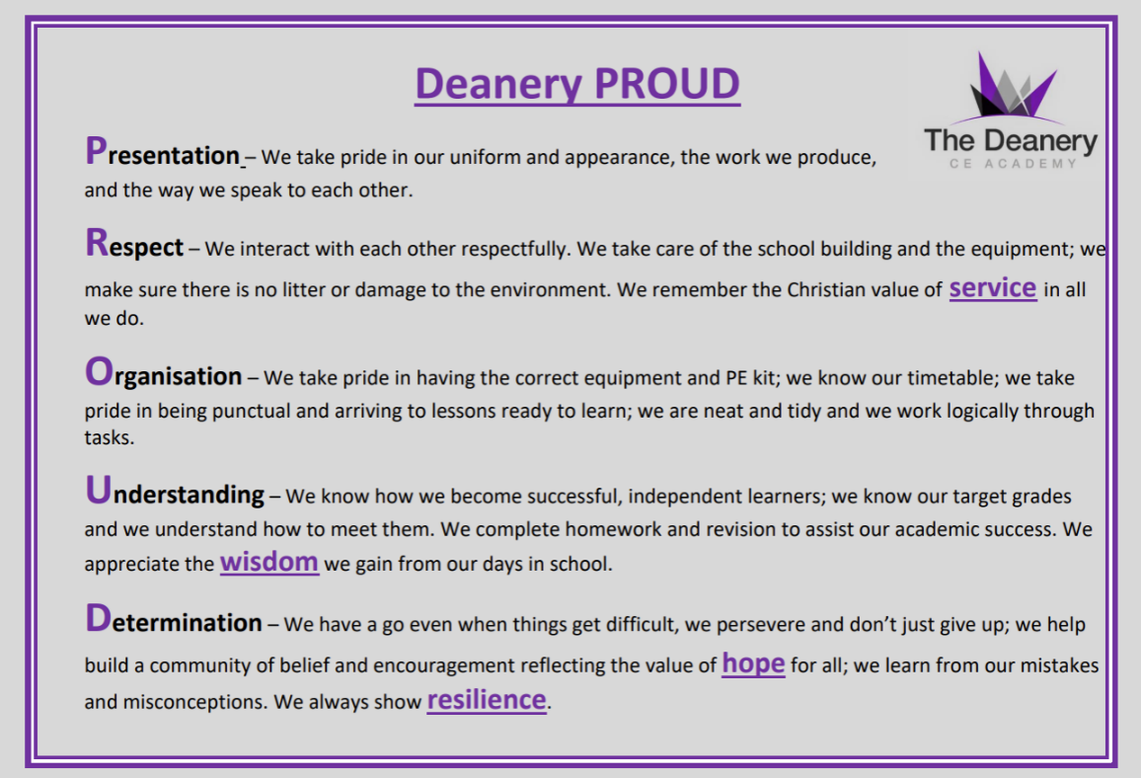
Edexcel Examination Board

- Maths
- History
- Computer Science

Pearson Examination Board

- Health & Social Care

OCR Examination Board

- Drama
- PE
- Sport Studies

Staff:
- Mr Young – Headteacher youngj@deanerycofeacademy.org.uk
- Mr McDonald - Deputy Headteacher (Curriculum) mcdonaldd@deanerycofeacademy.org.uk
- Ms Parry - Assistant Headteacher (Pastoral) parrys@deanerycofeacademy.org.uk
- Mrs Mathews - Assistant Headteacher (Performing Arts) matthewsd@deanerycofeacademy.org.uk
- Mrs Scotford – Assistant Headteacher (English) scotforde@deanerycofeacademy.org.uk
- Mrs Hockin – Associate Assistant Headteacher (Science) hockinc@deanerycofeacademy.org.uk
- Mrs Gallagher - Associate Assistant Headteacher (Humanities) gallaghers@deanerycofeacademy.org.uk
- Miss McCaig – Associate Assistant Headteacher (Maths) mccaigt@deanerycofeacademy.org.uk

WJEC Examination Board

- Hospitality and Catering

AQA Examination Board

- English
- Science
- Religious Studies
- Geography
- French
- Textiles
- Photography
- Fine Art

Revision:
- Sparx
- Enrichment on Tuesdays (from July in year 10)
- Pearson Edexcel Grades 9-1 revision guides

Foundation Tier 100% examination
Achievable grades: 1-5

Paper 1 - Non-calculator, 90 minutes, 60 marks
Paper 2 - Calculator, 90 minutes, 60 marks
Paper 3 - Calculator, 90 minutes, 60 marks
Key Facts
Qualification Name: GCSE Mathematics
Type: GCSE
Assessment: 100% Examination
Examination Board: Edexcel
Ebacc Subject: Yes
Further Information: Miss McCaig – Associate Assistant Headteacher (Maths) mccaigt@deanerycofeacademy.org.uk

Maths
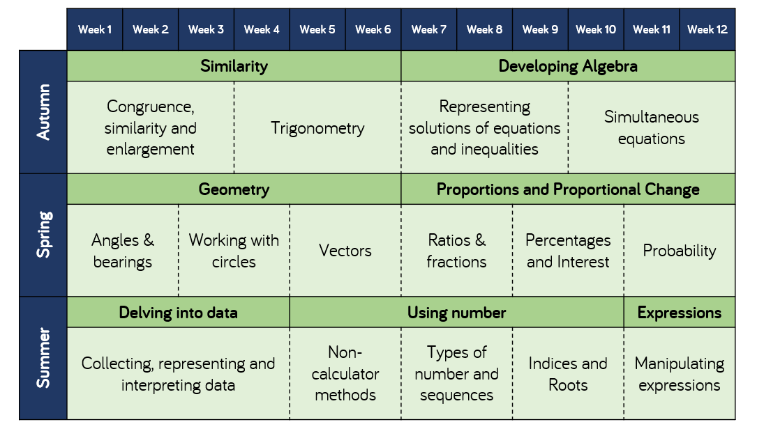
Higher Tier 100% examination
Achievable grades: 3-9

Paper 1 - Non-calculator, 90 minutes, 60 marks
Paper 2 - Calculator, 90 minutes, 60 marks
Paper 3 - Calculator, 90 minutes, 60 marks
Revision:

-Homework: Tassomai
- Website: Knowledge Organizers, past papers & online links www.dcea.org.uk/parent-information/our-curriculum/subjects/english/

Key Facts
Qualification Name: GCSE English Language
Type: GCSE
Assessment: 100% Examination – 2 exam papers
Tiered: No – all students sit the same papers
Examination Board: AQA
Ebacc Subject: Yes
Further Information: Mrs. Scotford (scotforde@deanerycofeacademy.org.uk)
English Language

Spoken Word
Separate compulsory element
Individual presentation to the class

Exam Paper | Length of Exam | Topic | Questions | Marks | /160
Language Paper 1  50% of Language GCSE | 1hr  45mins | Explorations in Creative Reading and Writing:  1x Fiction extract | Reading:  1 short form question  2 longer form questions  1 extended question | /4  2x /8  /20 | /80
Language Paper 1  50% of Language GCSE | 1hr  45mins |  | Writing:  1 extended writing question | /24 content & organisation  /16 SPAG | /80
Language Paper 2  50% of Language GCSE | 1hr45mins | Writer’s viewpoints and perspectives: 2x Non Fiction extracts | Reading:  1 short form question  2 longer form questions  1 extended comparison question | /4  1x /8 1x /12  /24 | /80
Language Paper 2  50% of Language GCSE | 1hr45mins |  | Writing:  1 extended writing question | /24 content & organisation  /16 SPAG  / | /80

Key Facts
Qualification Name: GCSE English Literature
Type: GCSE
Assessment: 100% Examination – 2 exam papers
Tiered: No – all students sit the same papers
Examination Board: AQA
Ebacc Subject: Yes
Further Information: Mrs. Scotford (scotforde@deanerycofeacademy.org.uk)
Revision:
-Homework: Tassomai
- Website: Knowledge Organizers, key quotations, past papers & online links www.dcea.org.uk/parent-information/our-curriculum/subjects/english/

English Literature

Exam Paper | Length of Exam | Questions | Marks | /160
Literature Paper 1  40% of Literature GCSE | 1hr45mins | Macbeth | 30 + 4 SPAG | /64
Literature Paper 1  40% of Literature GCSE | 1hr45mins | A Christmas Carol | 30 | /64
Literature Paper 2  60% of Literature GCSE | 2hr15mins | An Inspector Calls | 30 + 4 SPAG | /96
Literature Paper 2  60% of Literature GCSE | 2hr15mins | Power and Conflict Poetry | 30 | /96
Literature Paper 2  60% of Literature GCSE | 2hr15mins | Unseen Poetry (1 poem) | 24 | /96
Literature Paper 2  60% of Literature GCSE | 2hr15mins | Compare unseen poems | 8 | /96

Biology

Higher Tier - 100% examination
Achievable grades: 5-9
Paper 1 – Topics 1 -4
Paper 2 – Topics 5 -7
Plus Key Ideas
Foundation Tier - 100% examination
Achievable grades: 1 -5
Paper 1 – Topics 1 -4
Paper 2 – Topics 5-7
Plus Key Ideas
Key Facts
Qualification Name: GCSE Biology
Assessment: 100% Examination
Examination Board: AQA
Further Information: Mrs Hockin
hockinc@deanerycofeacademy.org.uk
Subject Content

- 1. Cell biology
- 2. Organisation
- 3. Infection and response
- 4. Bioenergetics
- 5. Homeostasis and response
- 6. Inheritance, variation and evolution
- 7. Ecology
- 8. Key ideas
Revision:
CGP Biology Revision Guide – Foundation or Higher
https://www.aqa.org.uk/subjects/science/gcse/biology-8461/specification-at-a-glance
https://www.physicsandmathstutor.com/biology-revision/gcse-aqa/

Chemistry

Higher Tier - 100% examination
Achievable grades: 5-9
Paper 1 – Topics 1 -5
Paper 2 – Topics 6 -10
Foundation Tier - 100% examination
Achievable grades: 1 -5
Paper 1 – Topics 1 -5
Paper 2 – Topics 6 -10

Key Facts
Qualification Name: GCSE Chemistry
Assessment: 100% Examination
Examination Board: AQA
Further Information: Mrs Hockin
hockinc@deanerycofeacademy.org.uk
Subject Content

- 1. Atomic structure and the periodic table
- 2. Bonding, structure, and the properties of matter
- 3. Quantitative chemistry
- 4. Chemical changes
- 5. Energy changes
- 6. The rate and extent of chemical change
- 7. Organic chemistry
- 8. Chemical analysis
- 9. Chemistry of the atmosphere
- 10. Using Resources
Revision:
CGP Chemistry Revision Guide – Foundation or Higher
https://www.aqa.org.uk/subjects/science/gcse/chemistry-8462/specification-at-a-glance
https://www.physicsandmathstutor.com/chemistry-revision/gcse-aqa/

Physics

Higher Tier - 100% examination
Achievable grades: 5-9
Paper 1 – Topics 1 -4
Paper 2 – Topics 5 -8
Key Facts
Qualification Name: GCSE Physics
Assessment: 100% Examination
Examination Board: AQA
Further Information: Mrs Hockin
hockinc@deanerycofeacademy.org.uk
Foundation Tier - 100% examination
Achievable grades: 1 -5
Paper 1 – Topics 1 -4
Paper 2 – Topics 5-8
Subject Content

- 1. Energy
- 2. Electricity
- 3. Particle model of matter
- 4. Atomic structure
- 5. Forces
- 6. Waves
- 7. Magnetism and electromagnetism
- 8. Space

Revision:
CGP Physics Revision Guide – Foundation or Higher
https://www.aqa.org.uk/subjects/science/gcse/physics-8463/specification-at-a-glance
https://www.physicsandmathstutor.com/physics-revision/gcse-aqa/

Science

Higher Tier - 100% examination
Achievable grades: 5-9
Each Paper worth 70 marks

Foundation Tier - 100% examination
Achievable grades: 1 -5
Each paper worth 70 marks

Examination code | Title | Subject Content
8464/B/1F | Paper 1 Foundation Tier - Biology | Topics 1 - 4
8464/B/1H | Paper 1 Higher Tier - Biology | Topics 1 - 4
8464/B/2F | Paper 2 Foundation Tier - Biology | Topics 5 – 7
8464/B/2H | Paper 2 Higher Tier - Biology | Topics 5 – 7
8464/C/1F | Paper 1 Foundation Tier - Chemistry | Topics 8 - 12
8464/C/1H | Paper 1 Higher Tier - Chemistry | Topics 8 - 12
8464/C/2F | Paper 2 Foundation Tier - Chemistry | Topics 13 - 17
8464/C/2H | Paper 2 Higher Tier - Chemistry | Topics 13 – 17
8464/P/1F | Paper 1 Foundation Tier - Physics | Topics 18 – 21
8464/P/1H | Paper 1 Higher Tier - Physics | Topics 18 – 21
8464/P/2F | Paper 2 Foundation Tier - Physics | Topics 22 – 24
8464/P/2H | Paper 2 Higher Tier - Physics | Topics 22 – 24

Key Facts
Qualification Name: GCSE Combined Science - Trilogy
Assessment: 100% Examination
Examination Board: AQA
Further Information: Mrs Hockin
hockinc@deanerycofeacademy.org.uk
Subject Content

Biology
- 1. Cell biology
- 2. Organisation
- 3. Infection and response
- 4. Bioenergetics
- 5. Homeostasis and response
- 6. Inheritance, variation and evolution
- 7. Ecology

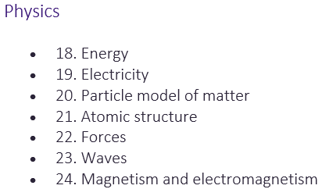
Chemistry
- 8. Atomic structure and the periodic table
- 9. Bonding, structure, and the properties of matter
- 10. Quantitative chemistry
- 11. Chemical changes
- 12. Energy changes
- 13. The rate and extent of chemical change
- 14. Organic chemistry
- 15. Chemical analysis
- 16. Chemistry of the atmosphere
- 17. Using resources
Revision:
CGP Combined Science Revision Guide – Foundation or Higher
https://www.aqa.org.uk/subjects/science/gcse/combined-science-trilogy-8464/specification-at-a-glance
https://dev.physicsandmathstutor.com/biology-revision/gcse-aqa/
https://dev.physicsandmathstutor.com/chemistry-revision/gcse-aqa/
https://dev.physicsandmathstutor.com/physics-revision/gcse-aqa/

Key facts
Qualification Name: GCSE Religious Studies A
Type: GCSE
Assessment: 100% Exam
Examination Board: AQA
EBacc Subject: No
gallaghers@deanerycofeacademy.org.uk
Paper 1 = Study of two religions: Christianity & Islam
(1hr 45mins exam)

Paper 2 = Study of 4 themes:
1. Religion & life
2. Religion, peace & conflict
3.Religion, crime & punishment
4.Religion, human rights & social justice
(1hr 45mins exam)

The full specification can be found here: https://www.aqa.org.uk/subjects/religious-studies/gcse/religious-studies-a-8062/subject-content/component-1-the-study-of-religions-beliefs,-teachings-and-practices
Religious
Studies

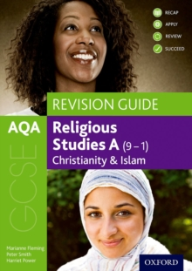

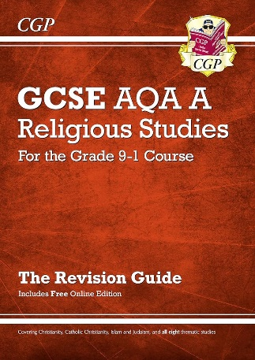
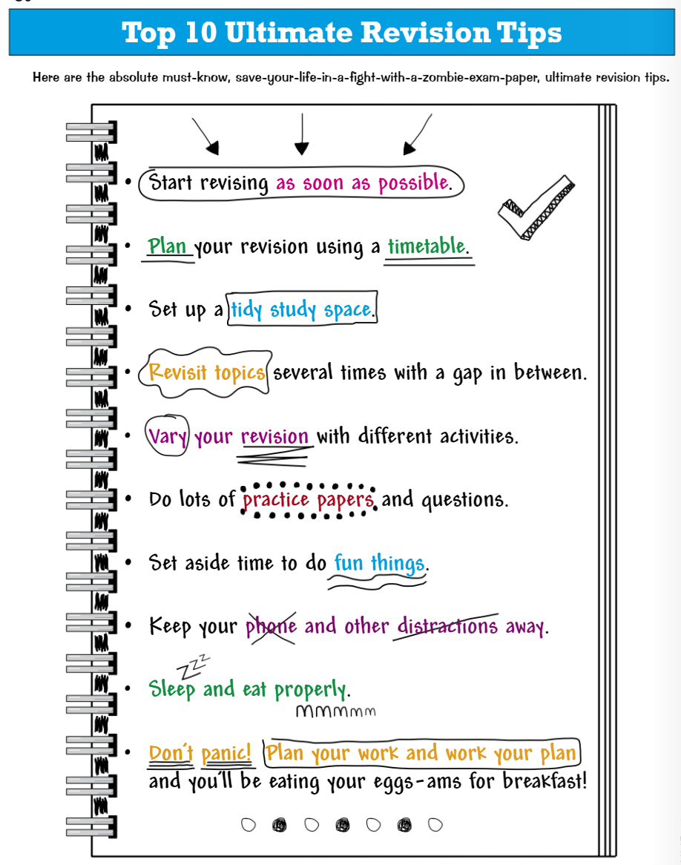

Useful Revision Tools








